Computer Components

OS: Nobora FREE
Great for gaming as it offers high frame rates compared to other operating systems in linux, and comes installed with davinci right off the gate!
https://nobaraproject.org

GPU: GeForce RTX 4070 Super $624
Nobora supports high end nvidia graphics cards, and considering the potential, at least a 600 dollar purchase would suffice.
https://www.amazon.com/MSI-RTX-4070-12G-Graphics

CPU: AMD Ryzen 7 7700X $288
Motherboard: X670 ATX Motherboard $259
Case: Fractal Design Focus G White ATX Mid Tower Computer Case $55
Went with the AMD because they are known to overheat less than intel branded ones, which in arizona is a HUGE deal. Also intel’s latency issues suck! Also because this is my first build, I’ll play it safe and just use the ATX branded case so I won’t have any issues in terms of physical.
https://www.amazon.com/AMD-7700X-16-Thread-Unlocked-Processor
https://www.amazon.com/ASRock-X670E-Support-Processors-Motherboard
https://www.newegg.com/white-fractal-design-focus-g-series-atx-mid-tower/p

RAM: DDR5 RAM 32 GB, 6000mhz, corsair $118
Need a lot to stream really well! Get one or two ram.
https://www.newegg.com/corsair-32gb/p/N82E16820982058

SSD: NVMe 2TB gen 5 MSI m570 $200
2TB because I want a lot of information.
https://www.newegg.com/msi-2tb-m570-hs/p/N82E16820140043?Item=N82E16820140043

Coolers: AIO Liquid Cooler $90
I live in a desert!
https://www.amazon.com/dp/B09VGX1WQH?ref=emc_p_m_5_i_atc

PS: EVGA Supernova 850 Plus Gold $115
Friend says EVGA is a good brand, and the cultist tier list states supernova is in A tier, so I shall go with this!
https://www.amazon.com/EVGA-Supernova-Certified-Capacitors-535-5G-0850-K1

Disc Drive: Ignore (for now)

Total: $1765.00 + Tax
411.17 + 1500.21 = 1911.38
Computer Parts

GPU (Graphics Card)
It is the transition between the motherboard and the output, as it has the outputs. Good options include Amd and Nvidia. AT LEAST 16 GB OF VRAM IS REQUIRED!! Nvidia is probably the best bet!
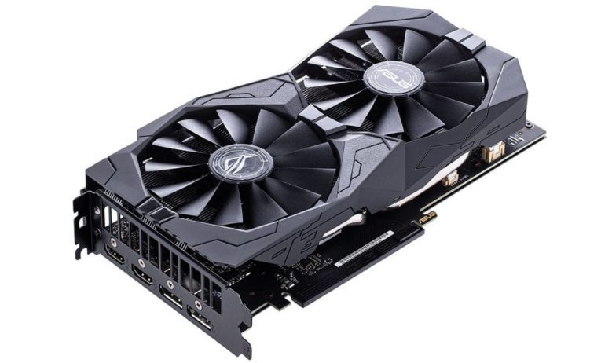

CPU (Central Processing Unit)
AMD and Intel are the major cpu makers. It is the brain of the computer and plugs into the motherboard. There are cores inside the computer which basically allows for the CPU to multitask depending on the amount of cores. Some cores can even multitask themselves, this is known as multithreading. Performance has more than one threading, while efficiency cores can only do one thread. Integrated graphics is bad.
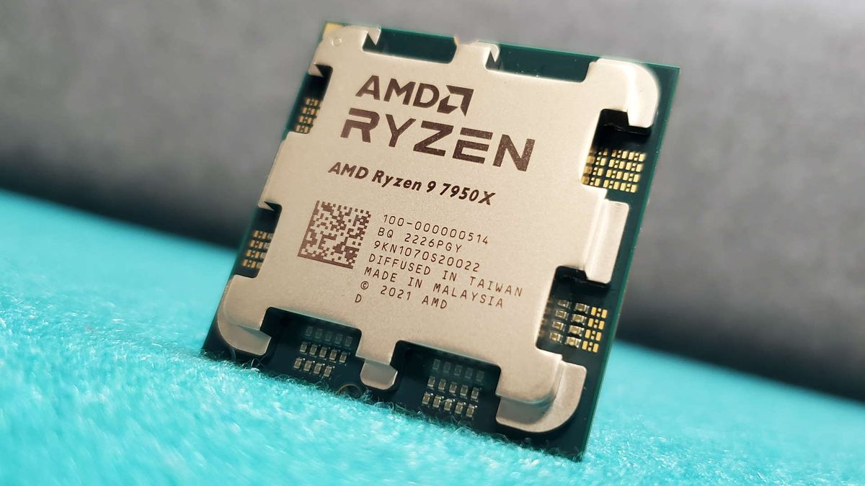

MotherBoards
There are several motherboards out there. One thing to note is using an AMD CPU chip with an Intel chipset will NOT work. Match the motherboard with the right chipset! There are three types of motherboards, ITX, mATX, ATX motherboards. Motherboards typically have everything involving controls. Look carefully at the VRM. Also to connect the graphics card and other cards there are different bandwidths to pay attention to. There is 1x, 4x, 8x, and 16x sizes. The fastest PCIE lanes are gen 4 or gen 5.
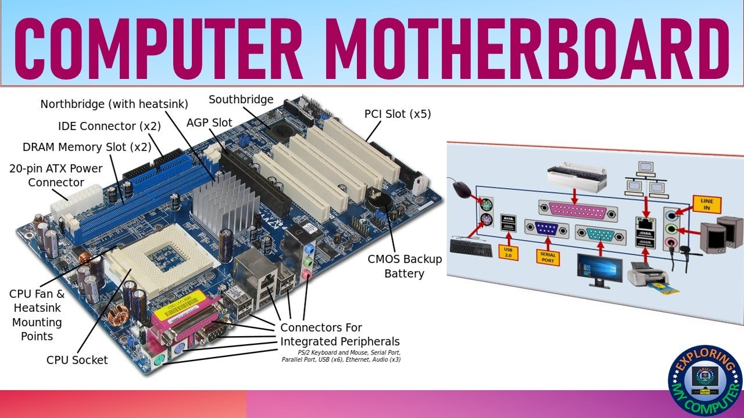

RAM (Memory)
Rams come in sticks called dimms and typically have 2 or 4 sticks.We want to use ram sticks in pairs.The motherboard will specify the type of ram to buy. The two main types are DDR4 and DDR5 rams. Faster ram does not always mean better performance. The cas latency determines the amount of clock cycles it takes to send data. The amount of ram will depend on what I want to do, for me at least 32 might be my best bet.
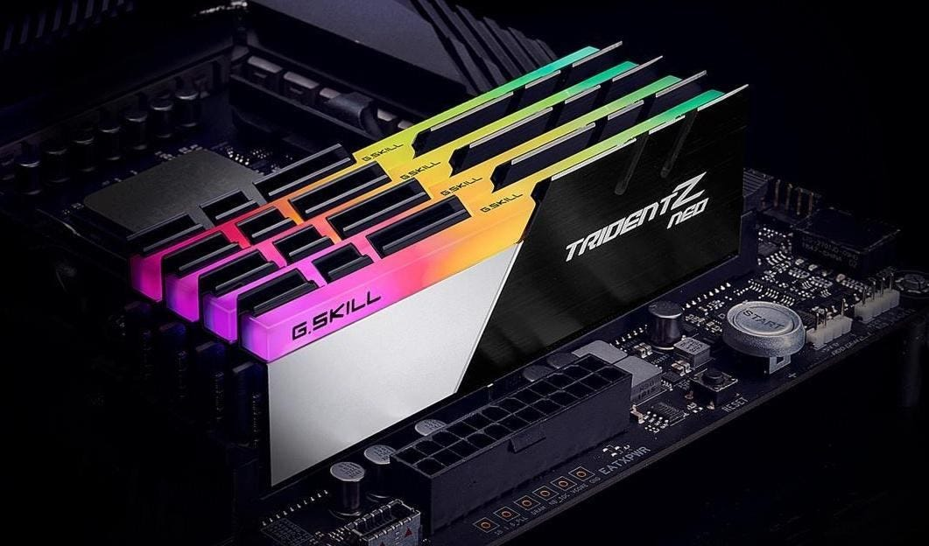
SSD (Storage)
Older computers used spinny disc storage, but that is being phased out, don’t use that. Instead use a smaller M.2 NVME SSDS. Get at least one terabyte of storage, maybe 2. SSD speeds are also important, also called gen. Don't bother with gen 5, gens 4 or 3 is gonna be the one we need. PCIE gens are actually backwards compatible, so a gen 5 can use a gen 3.
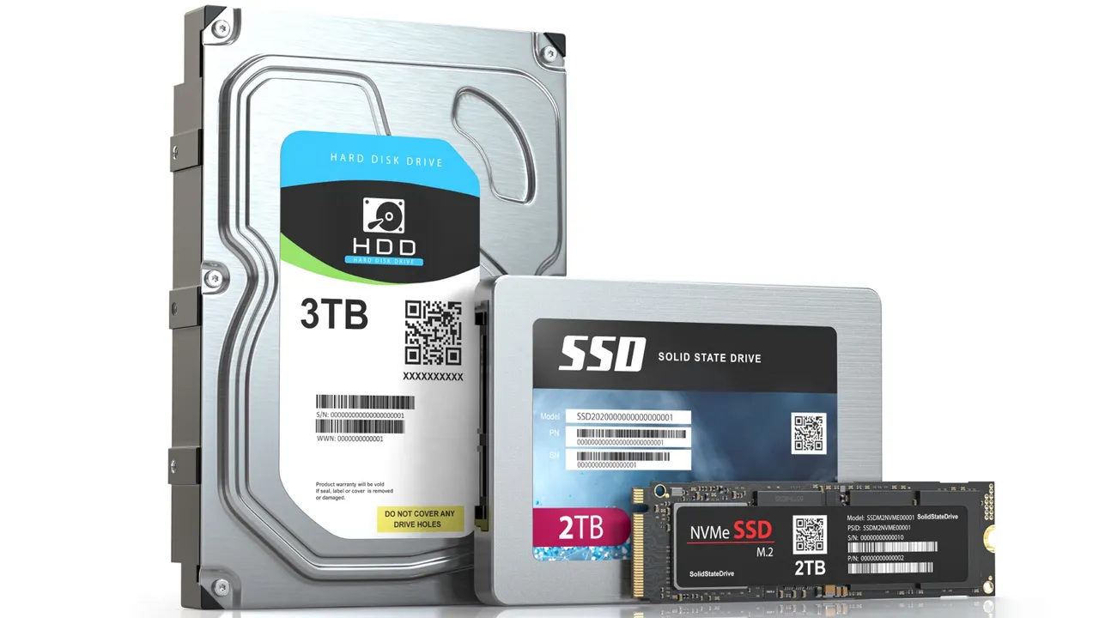

Coolers
Computers with faster chips cause the CPU to work harder. Because of this it requires more energy which leads to overheating. When the system overheats, it slows down the computer AND could be a fire hazard! Some cpus come with stock coolers to get started, but what we want is aftermarket coolers. There are two types, fan coolers and all in 1 liquid coolers called AIO.
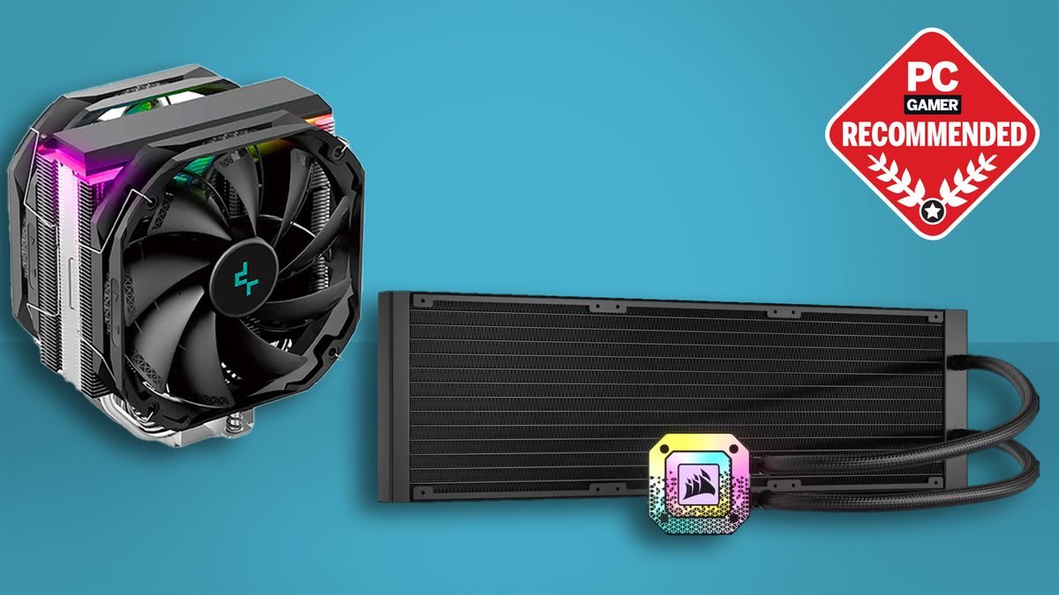

PC Case
There are a couple things to take note when getting a pc case. Number one is air flow which is how the coolers are cooling the machine and how the bad air is getting out. Second is getting the right size case for the motherboard.
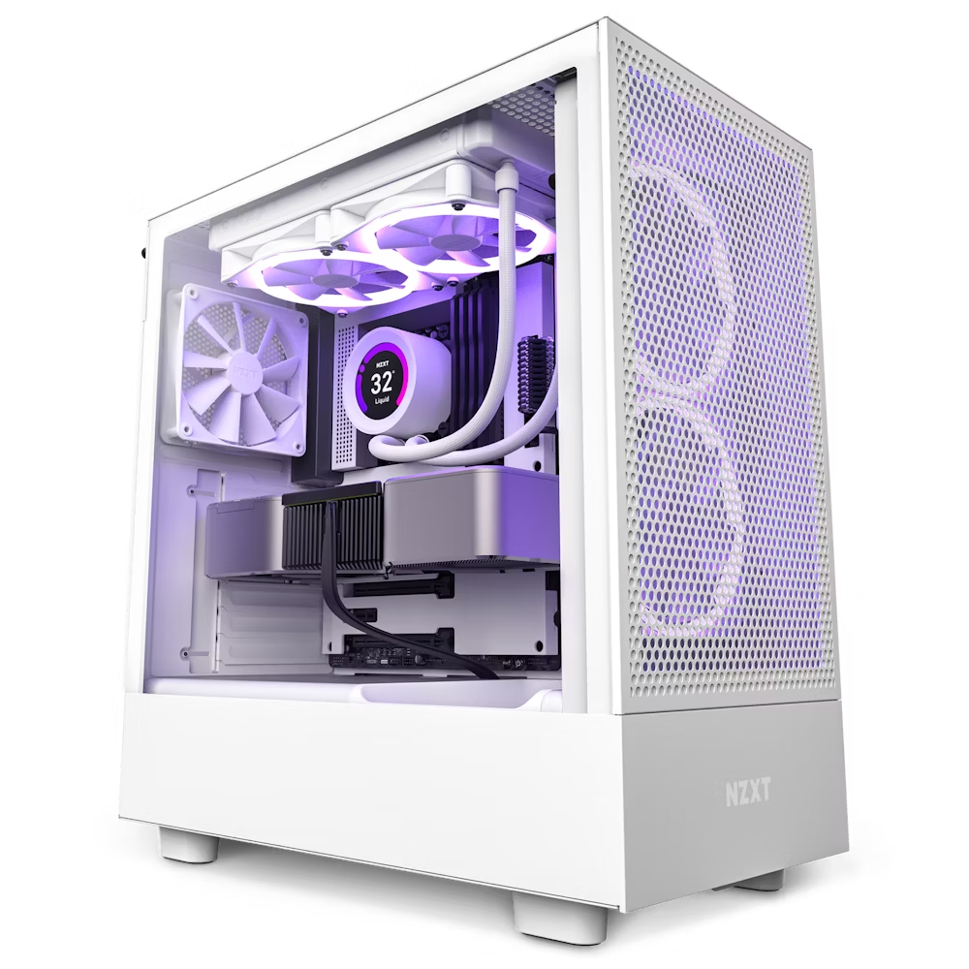

PSU (Power Supply)
They come in two main sizes, ATX which is the most common, and SFX for small form factors. Use the PSU cultist tier list to determine the best wattage or efficiency. Use a B or A tier PSU.
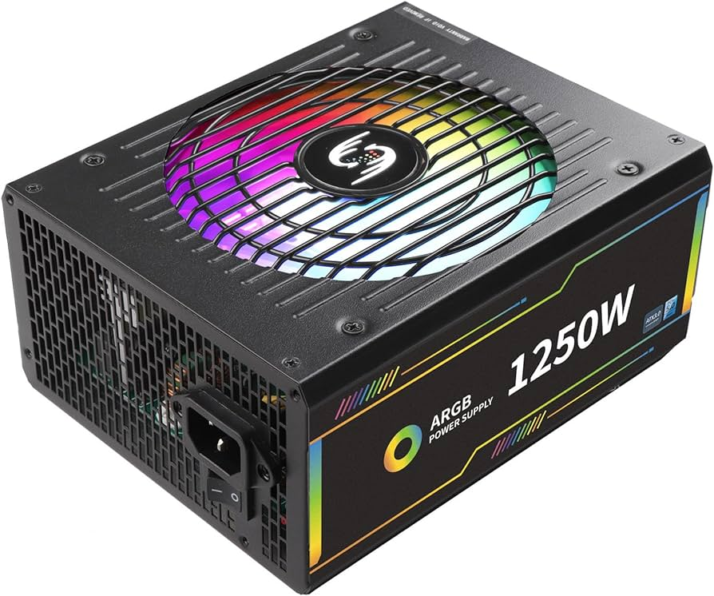
PC Monitor
1440p is the newest standard for gaming. The max FPS is 120-180 Hz. 240 hertz are becoming increasingly more common. It usually uses display ports, and uses VRR which prevents screen tearing.
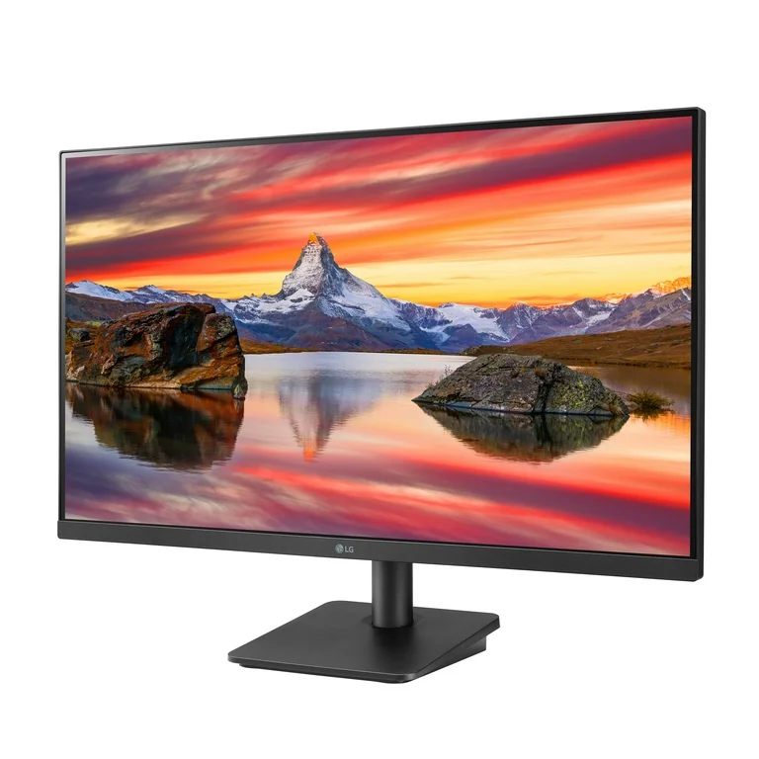

Linux Command Line

Man
Opens up the manual for the command

Pwd
Let’s you see the current directory you are currently in

Cd
Change the directory to a different one. Use .. to move up one directory

ls
List current directory’s content. Using -l will display everything

How to hide folders
You can hide files by putting a . in front of the name

Mkdir
Make a directory or a new file

Rmdir
It removes a directory

File
It gives the information of the file selected

Touch
Create empty files

Rm
Remove files or directories

Cp
Copy command, -r copies directory

Mv
It allows you to rename files and move them to other locations

Head
It outputs the first 10 lines of the file

Tail
It outputs the last 10 lines of the file

Cat
Print out all the content of any amount of multiple files. It also allows you to write simple text files like cat > file1.txt and you can write until you hit control d.You can also copy files.

Echo
Allows to display information, “echo big >text2.txt”

More
It forces out data to your terminal

less
It forces out high data to your terminal

Uptime
Tells you how long the system has been running

Free
Displays amount of memory usage

Ps
Snapshot of all the processes, use -a and you can kill a process

Df
Reports disc space, use -h to READ the command

Fdisk
You can manipulate partition tables, large storage devices that are divided into sections -l

Lsblc
Lists block devices, nonvolatile mass storage devices whose info can be accessed in any order. A gooey is a tool for transforming command line interfaces into beautiful desktop applications. So it's the desktop loader basically

Top
Displays linux processes, which is a lot

Htop
A WAY better way to troubleshoot applications, to install type “sudo apt install htop”

Ipconfig
To install it type “sudo apt install net-tools”, it is to get the ip information on your system

Ip
A way more detailed command version of ipconfig.
Sudo
Superuser do. It is used to activate restricted files in operations, because linux restricts more sensitive files.

Apt
Advanced management tool, It is used to install update packages, the best way on linux to install packages

Update
To check for updates on the system, used in tangent with sudo and apt

Upgrade
How to update the packages, used in tangent with sudo and apt

Search
It searches for the package you searched, used in tangent with sudo and apt

Install
Used to installed packages, used in tangent with sudo and apt

Remove
Used to remove packages, used in tangent with sudo and apt

Nano
How to access the nano text editor

Vim
How to access the vim text editor
Nano editor

Write out
Write the changes to the selected file

Read file
How to load the files

Where is
Looking for something in a big file

Cut text
Cuts whole line

Paste text
Cuts, then paste

Go to line
It will throw a error and tells which line it is.

Exit
Use control and then x

–no-sandbox
For running programs that makes the nvidia graphics card sad :(
/opt/r2modman/r2modman -no-sandbox
File Structure of Linux

Bin
Most of the binary files are stored, including most core utilities.

Boot
Do not play around with this directory, including gru

Cd rom
Discs

Dev
Hard Drives are stored here, and mounted

Etc
Where are the configuration files are stored

Home
Where all the username folders are stored

Lib
Libraries, they are files that are needed to work on linux

Media
Where external devices pop up in there

Mnt
Mounting, making files available for use at a particular location

Opt
Optional software, mostly depends on distribution

proc
The process folder, a lot of system information is placed

Root
The home directory for the home directory, don’t use it

Run
Only relevant to desktop environments. It will automatically automount.

Sbin
Dedicated to certain commands that can be only run by root user

Tmp
Where files are temporarily stored

Snap
A new way of installing applications, called snap packages

Usr
Utilities shared between users

Var
Where variable data is kept, like user logs

Swapfile
Extra place to store things that are stored in memory that have not been used for awhile

DVDbackup
Backup’s dvds

nobara-sync cli
Trobule with pccput

sudo dnf5 remove $(dnf repoquery --installonly --latest-limit=-1 -q)

Before Kernel Update

IPHONE:
REMEMBER 3UTOOLS

